CMPE 493

AT32UC3C

* Microchip Technology Inc. product page: <https://www.microchip.com/wwwproducts/en/AT32UC3C2512C>
* datasheet: <http://ww1.microchip.com/downloads/en/DeviceDoc/doc32117.pdf>

Atmel ICE - Hardware

User Guide

* <http://ww1.microchip.com/downloads/en/DeviceDoc/Atmel-ICE_UserGuide.pdf>

Atmel Studio 7 - Software

* <https://www.microchip.com/mplab/avr-support/atmel-studio-7>
* We will be programming board using JTAG:
  + *“JTAG programming on Atmel megaAVR devices is clocked by the programmer. This means that the programming clock frequency is limited to the maximum operating frequency of the device itself. (Usually 16MHz.)”*
* Setting up the Atmel-ICE in Atmel Studio 7:
  + <https://www.instructables.com/id/Atmel-Startup-1-Atmel-Studio-and-Programmer/>

Getting Started Guide

* <http://ww1.microchip.com/downloads/en/DeviceDoc/Getting-Started-with-Atmel-Studio7.pdf>

Atmel-ICE

* Basic kit only comes with:
  + Atmel-ICE
  + USB Cable
  + 10-pin 50-mil cable connector (goes into our board)
* USB drivers should install first time it is plugged in
* Connect 40-mil 10-pin flat cable directly to board and then use the AVR connector port on the Atmel-ICE
* Pin Description:

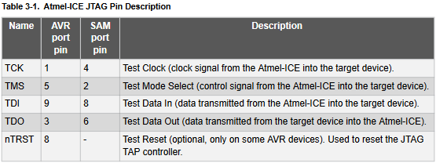

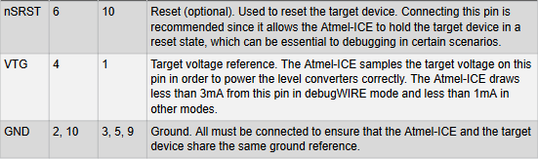

Programming the AT32UC3C2512C-A2UT from Atmel Studio 7

* click the ‘build’ tab in the top menu bar → click ‘build solution’ → check output console for ‘build succeeded’ message or errors
* click ‘tools’ tab in top menu bar → click ‘device programming’
* select ‘Atmel ICE’ under ‘Tool’ and ‘JTAG’ under ‘Interface’
* from here on we need to experiment:
  + for ‘Device’ experiment between ‘AT32UC3C2512C’ and ‘AT32UC3C0512C’
  + try to read the device signature w/ the PCB reset switch engaged and disengaged
  + try erasing the chip if the security bit is set
  + look for an .elf file

JTAG

* [see at32uc3c2512 datasheet Sec. 39.4.6]